360 Grand Avenue #150
Oakland, CA 94610
415-929-8876 • www.turn.org

Lower bills. Livable planet.
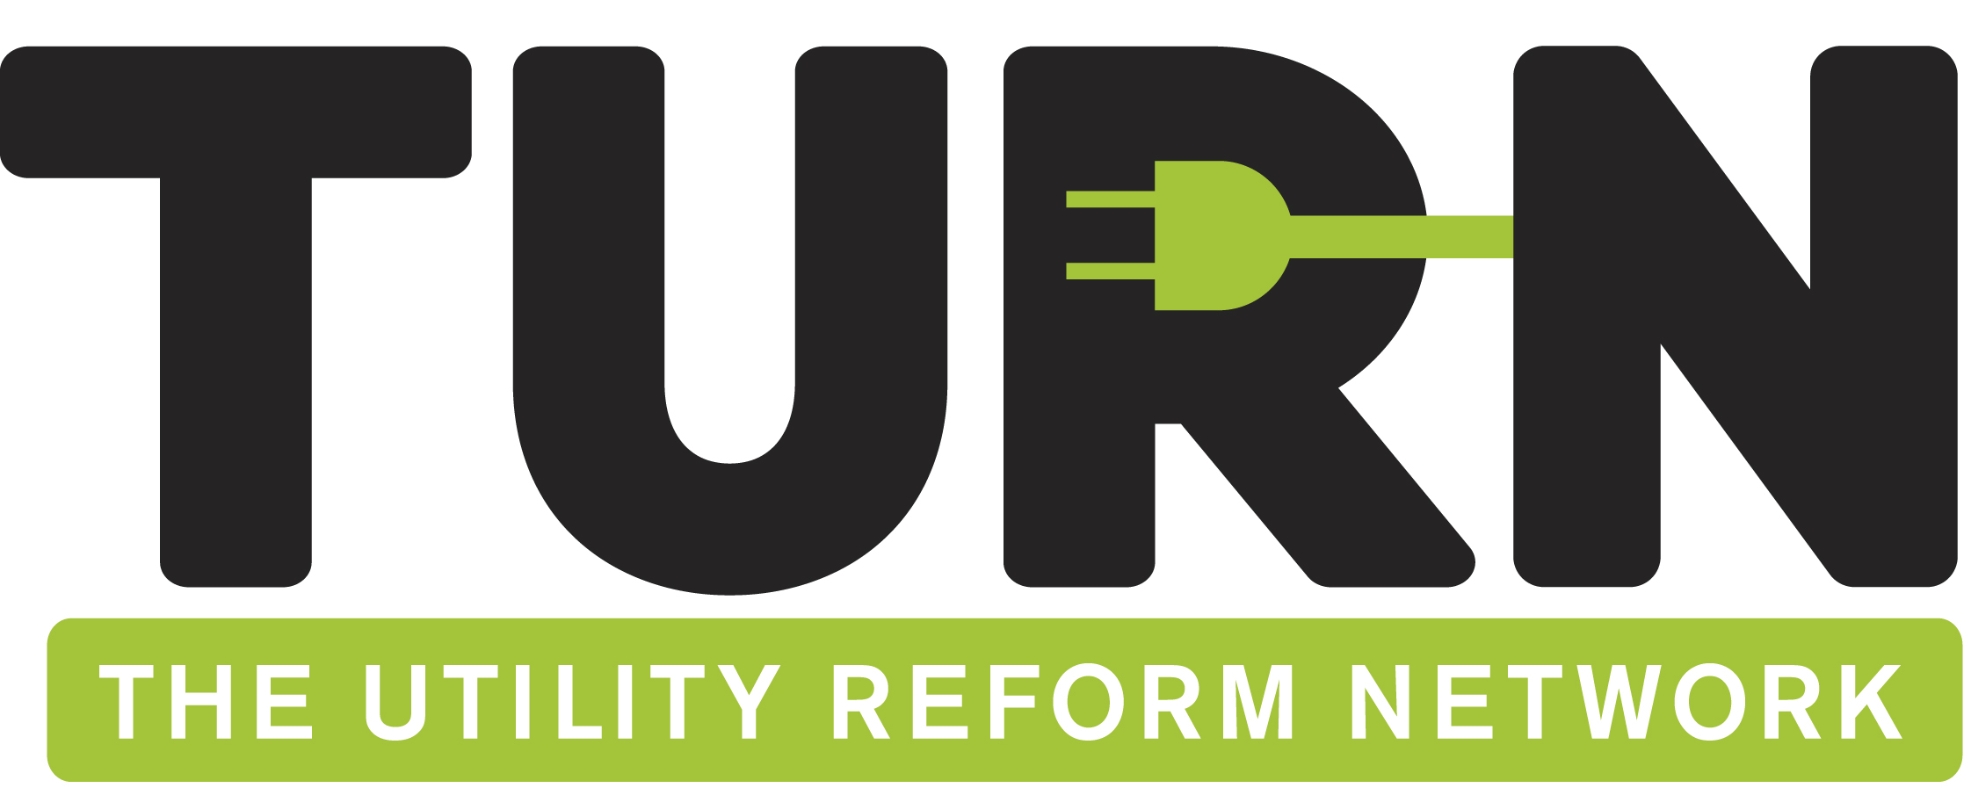

April 15, 2025

Senator Josh Becker
Chair, Senate Committee on Energy, Utilities and Communications
1021 O Street, Room 3350
Sacramento, CA 95814

Re: SB 540 (Becker) – OPPOSE UNLESS AMENDED
Senate Energy, Utilities and Communication Committee – April 21, 2025

Dear Senator Becker,
The Utility Reform Network (TURN), a consumer advocacy organization that has fought on behalf of California residential utility customers for more than 50 years, opposes SB 540 (Becker) unless amended. This bill would authorize the California Independent System Operator (CAISO) to rely on voluntary wholesale energy markets governed by an independent Regional Organization (RO). This authorization would represent a significant shift in control over energy markets along with a broadening of the market actors participating in a single regional market that includes California utilities and other California load serving entities. This shift may expose California customers to new risks that could prove difficult to mitigate.
TURN was strongly opposed to legislation in prior years that would have transformed CAISO into a Regional Transmission Organization by eliminating the Governor-appointed, Senate-confirmed board and merging the individual balancing authority areas associated with all the participating transmission owners. By preserving CAISO’s governance structure and its role as a balancing authority, SB 540 represents a different, and more cautious, approach to the development of regional energy markets. Despite the incremental nature of this new approach, TURN remains concerned that SB 540 currently contains insufficient safeguards to protect California consumers if the RO adopts market rules that frustrate key state environmental, resource planning, reliability or other public interest policies. These adverse outcomes have become more likely given recent announcements by the Trump administration indicating an intention to prioritize coal-fired generation, devalue production from clean energy resources, and challenge the legitimacy of state climate policies.
TURN has been working with the author of SB 540 on various concerns relating to the RO and hopes that they can be addressed through amendments. Specifically, TURN recommends amendments to accomplish the following:
- Clarify that the RO’s tariffs must permit California to withdraw its utilities from the regional market without penalties or any need for additional approvals by the Federal Energy Regulatory Commission (FERC). This element of the RO tariff must be approved by FERC prior to CAISO agreeing to cede its governance of these markets. The Legislature may wish to consider a requirement that a joint concurrent resolution be enacted after FERC approves the relevant tariff but prior to the transition.

- The RO must be prohibited from establishing any requirements relating to resource adequacy, reserve margins or reliability. Further the RO must not be allowed to rely on a centralized capacity market or separate energy markets for dispatchable, firm and intermittent resources. These prohibitions are necessary because the Trump administration has indicated its intent to intervene in wholesale markets for purposes of favoring coal and gas generation and marginalizing renewable energy resources. Successful federal intervention would be far more likely if the RO managed requirements, policies or markets that go beyond the proposed Extended Day Ahead Market (EDAM).

- Authorize the California Public Utilities Commission to direct the Investor Owned Utilities (IOUs) to withdraw from the RO if there are any violations of the obligations laid out in SB 540 or changes to RO-governed markets that harm California consumers or frustrate California resource planning, procurement, environmental, reliability or other public interest policies.

- Require California IOUs and Publicly Owned Utilities (POUs) to withdraw from the RO if legal challenges result in a court ruling that any California resource planning policy (including the Renewables Portfolio Standard (RPS)) impermissibility discriminates against out-of-state resources. This protection is necessary in light of the increased risk that participation in the RO, combined with strict delivery requirements to the CAISO balancing authority area, could embolden various market participants to pursue legal challenges to California’s resource planning and RPS rules.

- Require California IOUs and Publicly Owned Utilities (POUs) to withdraw from the RO if actions taken by the federal government force California consumers to subsidize out-of-state fossil generating resources under Section 202 of the Federal Power Act. President Trump has already indicated an intention to use Section 202 to force all participants in energy markets to subsidize fossil generation at risk of retirement.

- Require California IOUs and POUs to withdraw from the RO if a Joint Concurrent resolution is passed by the State Assembly and State Senate.

- Clarify that the RPS requirements relating to energy delivery from resources outside of a California Balancing Authority must satisfy strict standards including the use of dynamic scheduling, pseudo ties, or firm transmission rights. These clarifications are needed in light of changes to energy market rules and practices under EDAM.
The adoption of amendments responsive to these concerns would allow TURN to remove our opposition. While we recognize the potential benefits of an efficiently administered regional energy market, the risk of adverse outcomes to California consumers and California policy leadership must be fully addressed in this bill.
For more information about TURN’s position, please contact the Hernandez Strategy Group at (916) 447-9719.

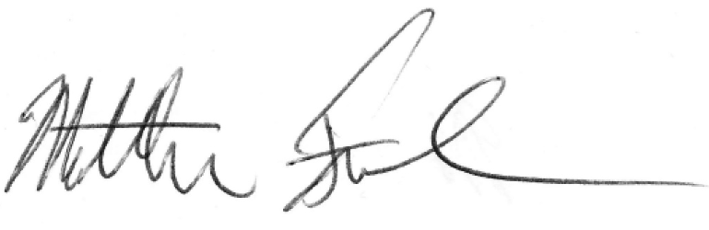
Sincerely,

Matthew Freedman
Staff Attorney

Cc: Members, Senate Energy, Utilities and Communications Committee
Senator Josh Becker

https://www.whitehouse.gov/presidential-actions/2025/04/strengthening-the-reliability-and-security-of-the-united-states-electric-grid/
https://www.whitehouse.gov/presidential-actions/2025/04/protecting-american-energy-from-state-overreach/

