Introduction

As part of the evolving energy landscape, SPP recognizes that a long-term vision of Planning Reserve Margin (PRM) requirements is a desirable and necessary policy goal for meeting the energy and capacity needs of the future. This policy paper outlines the framework for establishing long-term planning horizon PRM requirements in a way that minimizes alterations to those requirements with adequate advance notice leading up to the applicable operating season.

Principles for setting Long-Term PRM requirements
Load Responsible Entities (LREs) have expressed the need for more clarity on resource planning in a long-term horizon. SPP should develop policy and methodologies to improve the analysis and determination of long-range PRM requirements. These policies will provide state regulators with the framework for establishing Long-Term PRM requirements intended to provide LREs insight into their long-term resource planning needs.
Additionally, to increase planning certainty, there should be appropriate consideration of risk in setting Long-Term PRM requirements so that the need for subsequent adjustments to those established requirements is minimized. However, all stakeholders should recognize longer-term planning intrinsically involves more uncertainty. SPP can provide best estimates of long-term resource needs, giving LREs more planning information, but LREs share the obligation to plan for the future and will make individual business decisions and risk assessments to maintain appropriate capacity reserves to ensure future resource adequacy. The purpose of a long-term PRM is not for SPP to supplant long-term planning at the LRE level; the purpose is to provide LREs more forward-looking information to make better-informed long-term planning decisions.

PRM Enablers
There are several policies and methodologies that will need to be developed and implemented concurrently to adhere to the principles stated above. These include:

Expected Future Resource Mix
Ensure adequate representation of resource forecasts when establishing a Long-Term PRM. Determine if additional uncertainty is needed in a Long-Term PRM to account for changing resource assumptions. Consider encouraging methods that increase resource forecast accuracy in Long-Term PRM risk.

Demand Response
Develop comprehensive Demand Response (DR) policies for proper operational deployment and accreditation. DR has the potential to be one of the fastest growing ‘capacity’ types moving forward. The accreditation that is assigned to DR programs should represent the reliability contribution that can be confidently depended upon by the power system.

Load Forecasting Enhancements
Develop load forecasting enhancements to ensure PRM requirements can be established and administered with a reasonable degree of confidence and consistency. The risk of sudden increases in load growth and profile shifts as a result of new large loads – i.e., data centers, crypto mining, electric vehicle charging, electrification of industry that is currently natural gas dependent – will need to be addressed, as sudden increases in load growth that are not foreseen in the long-range load forecasting processes can quickly reduce any anticipated excess or needed capacity.

Transmission Infrastructure for New Resources
Accelerate access to transmission infrastructure for new resources. The need to continuously improve the Generator Interconnection process so that more generation can be interconnected quicker will be increasingly critical to meet future PRM requirements. Additionally, improvements for the load interconnection process should be evaluated.

LOLE Study Consistency
Standardize Loss of Load Expectation (LOLE) study processes to minimize future variability not associated with changing conditions. While it is important to continuously improve study processes to improve accuracy and keep up with industry trends and developments, it is also important to maintain consistency in study methodologies. Allowing changes to inputs, sensitivities, and analyses to be included in the LOLE study process will need to be appropriately limited to maintain stability in PRM values.

Continue to address Real-time and Resource Adequacy gaps
Better align LOLE study processes with operational experiences. Much effort has been made, and progress has been accomplished to align planning and operational processes. However, there are still methodology gaps that have created mismatches between operational observations and longer-term planning expectations of the system.

Alternatively, market policy and operational practices may also need to be considered in order to address gaps.

Framework for mid-term to long-term PRM setting
As a general framework, all PRM expectations established for future years will be documented as requirements. These future PRM requirements that have been established may be adjusted in subsequent years, as discussed below. When those adjustments occur, they will be documented as the new PRM requirement for the applicable season/year.

Uncertainties to be considered in Long-Term PRM development
The process of setting the Long-Term planning horizon PRM requirements should evaluate the risk of changes to underlying assumptions such as the resource mix and load. With a minimum of a Year 4 study structure, 5 years will pass between the time when inputs are provided to SPP and the operational time studied. Mitigations may include tighter reliability thresholds of metrics, such as LOLE or Expected Unserved Energy (EUE); however, such mitigations should consider impacts to affordability.
Establishment of Long-Term planning horizon PRM requirements should consider the known risks in the operational horizon. This will require a data driven approach to continued alignment of the planning models with operational realities. This may include modification to study assumptions such as planned maintenance outages or the inclusion of operating reserves, or modification of related policy, such as load forecasting, market rules, or outages.

Advanced Notice of PRM Changes and Associated Risks to be Mitigated
While there is agreement that LREs need advance notice of PRM requirement changes, it is important to establish a correlation between the amount of advanced notice given and the uncertainty risk that must be mitigated. This correlation of uncertainty throughout the planning horizon and the risk that must be mitigated should be anticipated and included in the final PRM requirement.
Long-Term PRM requirements should be set by analyzing the mid-term to long-term planning horizon on a periodic basis. The current tariff prescribes that the LOLE study be performed biennially or more often as needed. Recent practice has included study years in the near and mid-term planning horizon (Year 2 and Year 5 analyzed for each study), while the 2023 LOLE study slightly adjusted that practice and analyzed Year 3 and Year 6.
Analyzing the long-term planning horizon beyond Year 6 may give LREs a better understanding of future PRM requirements, but the certainty of this understanding will be highly dependent upon subsequent deviations from those resource mix assumptions. Additionally, setting the PRM in a manner that will result in minimal subsequent changes to allow LREs time to plan and construct generation is a desired goal. This could be considered the “set it and forget it” year – e.g., 4 years notice – i.e., “Year 4”.
As shown below, the study and approval cadence approved by SAWG should be adhered to for future long-term PRM determination.
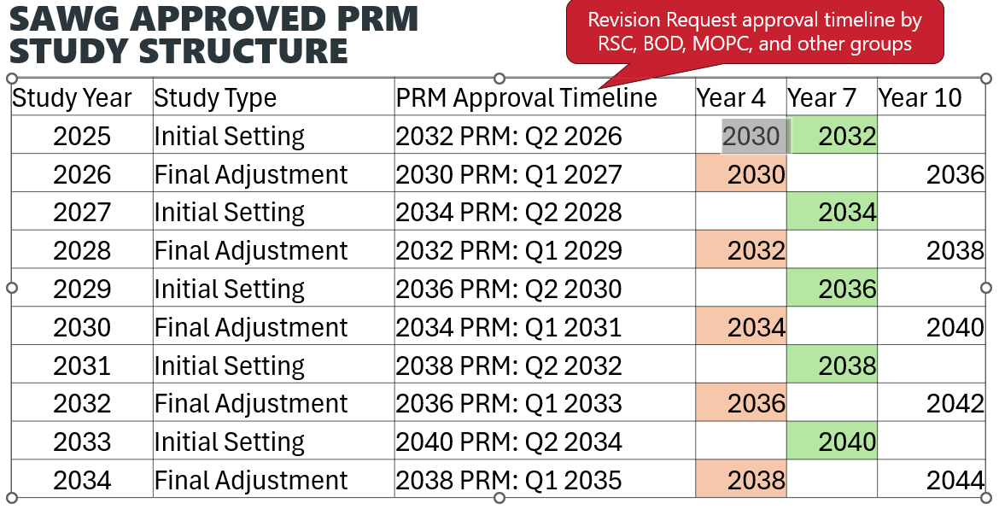
By employing a process that analyzes years beyond Year 4 (e.g., Year 7 and Year 10), a view of the PRM can be set for LREs’ visibility that will educate their resource planning for Year 4 while also offering insight into the long-range trajectory for Year 7 and Year 10.
To accomplish this goal, a LOLE study progression of analysis years should follow this cadence.
      - Odd numbered years – develop and implement any new study methodologies that may impact study results – Study Year 7. Use the latest and most up-to-date LRE resource plans and load forecasts.
      - Even numbered years – use the methodologies implemented in the previous year’s analysis and update the resource plan and load forecast to Study Year 4 and Year 10.
This cadence will allow LREs to observe the trajectory of a certain year and be able to plan accordingly. For instance, study year 2036 will first be analyzed in the Year 10 study of the 2026 LOLE study. It will then be analyzed again in the Year 7 study in the 2029 LOLE study. Its final value will be set (‘set it and forget it’) in the 2032 LOLE study for Year 4.

Conclusion
As part of the evolving energy landscape that SPP is currently navigating, SPP recognizes that a longer-term vision of Planning Reserve Margin requirements is a desirable and necessary policy goal for meeting the energy and capacity needs of the future.
Long-Term PRM requirements should…
- Be documented as a requirement
- Be allowed to be updated after the initial setting, but no changes are allowed once the year is evaluated in a Year 4 study (approximately 3.5 years in advance of requirement). The final evaluation will take into account the latest LOLE study methodologies
- Recognize and consider mitigation for the risk necessary to account for potential changes in the resource mix and other uncertainties that may occur in the 4 years after the PRM value is last evaluated.
- Recognize and consider the inclusion of mitigation to account for operational flexibility and uncertainties.

