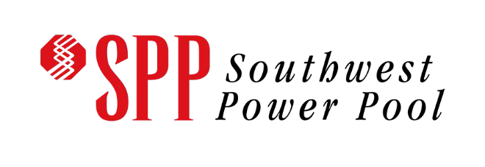 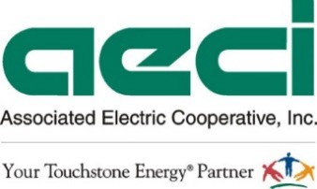

2024 AECI-SPP Joint & Coordinated System Plan Final Report

#### Published on 10/25/2024 By AECI-SPP Joint Planning Committee

SECTION 1: STUDY OVERVIEW 3

1.1 : INTRODUCTION 3

1.2 : STUDY OBJECTIVE 3

1.3 : STAKEHOLDER COLLABORATION 3

1.4 : MODEL DEVELOPMENT 5

1.5 : PLANNING STANDARDS 6

1.6 : NEEDS ASSESSMENT 6

1.7: SOLUTION ANALYSIS 8

SECTION 2: RECOMMENDATIONS 9

2.1 : PROJECTS OF INTEREST 9

2.2 : PRELIMINARY ADJUSTED PRODUCTION COST BENEFIT EVALUATION 15

2.3 : STUDY RECOMMENDATIONS 15

2.4: FUTURE STUDY PROCESS ENHANCEMENTS 15

## SECTION 1: STUDY OVERVIEW

### : INTRODUCTION

This document presents an overview of the assessment process and the results of the 2024 Associated Electric Cooperative Inc., (“AECI”) - Southwest Power Pool (“SPP”) Joint and Coordinated System Planning (“JCSP”) study. The AECI-SPP JOA requires a JCSP study to be performed every other year to ensure the reliable, efficient, and effective planning and operation of the transmission system along the AECI-SPP seam. The requirements and guidelines of the study can be found in Article 7 of the AECI-SPP JOA[1]. SPP and AECI staff, along with stakeholders through the AECI-SPP Interregional Planning Stakeholder Advisory Committee (“IPSAC”), collaborated throughout the first half of 2024 on the performance of a JCSP study to identify potential joint transmission projects that are mutually beneficial to both entities.

### : STUDY OBJECTIVE

The primary objectives of the 2024 JCSP study include:

1. Evaluate the reliability and robustness of the combined SPP and AECI transmission systems, focusing on specific target areas identified by stakeholders and staff,
2. Collaborate on the development of mutually beneficial transmission solutions, and
3. Identify transmission upgrades with potential for cost-sharing
4. Provide information necessary to support cost-sharing negotiations and applicable upgrade approval processes, ultimately resulting in the construction of mutually beneficial facilities

The geographic focus of the 2024 JCSP study was the areas surrounding the SPP – AECI seam, with additional emphasis on the areas most affected by Winter Storm Elliott: Northeast Oklahoma, Southwest Missouri, and Northwest Arkansas.

### : STAKEHOLDER COLLABORATION

Assumptions and procedures for the 2024 JCSP study analysis were developed through SPP and AECI joint stakeholder meetings that took place throughout the first half of 2024. The AECI-SPP IPSAC, which is comprised of SPP and AECI stakeholders, was the joint stakeholder committee primarily responsible for overseeing the 2024 JCSP study. IPSAC meetings were held on the following dates, and future meetings have been planned:

* December 15, 2023[2]
  + Scope Development and Approval
* March 22, 2024[3]
  + Review of Needs Identified
* August 2, 2024[4]
  + Review of the most promising improvements

Periodic study updates were also provided to the following AECI and SPP stakeholder groups:

* SPP Seams Advisory Group
* SPP Transmission Planning Summit
* AECI G&T Operations Committee

### : MODEL DEVELOPMENT

##### STUDY YEARS AND SEASONS

The 2024 JCSP study horizon included modeling of the transmission system for the next ten years, which will provide lead time so that appropriate approvals may be obtained, and project owners can begin work promptly.

SPP and AECI utilized the SPP 2024 ITP Base Reliability Model Series to perform the Study. Model years 2025, 2028, and 2033 were analyzed in the Study for the following seasons: 2025 summer peak, 2025 winter peak, 2028 light load, 2028 summer peak, 2028 winter peak, 2033 summer peak, and 2033 winter peak. SPP built two power flow models to mimic the winter weather model set based upon Winter Storm Elliott. AECI’s area in the SPP 2024 ITP Base Reliability Models was reviewed and updated for accuracy and the nine model scenarios are summarized in Table 1 below:

Table . Study Model Descriptions

|  |  |  |
| --- | --- | --- |
| **Description** | **Base Reliability** | **Extreme Winter Scenario** |
| Year 2  (2025) | Summer Peak  Winter Peak | Winter Peak (based on Winter Storm Elliott – December 2022 |
| Year 5  (2028) | Summer Peak  Winter Peak  Light Load | Winter Peak (based on Winter Storm Elliott) |
| Year 10  (2033) | Summer Peak  Winter Peak |  |

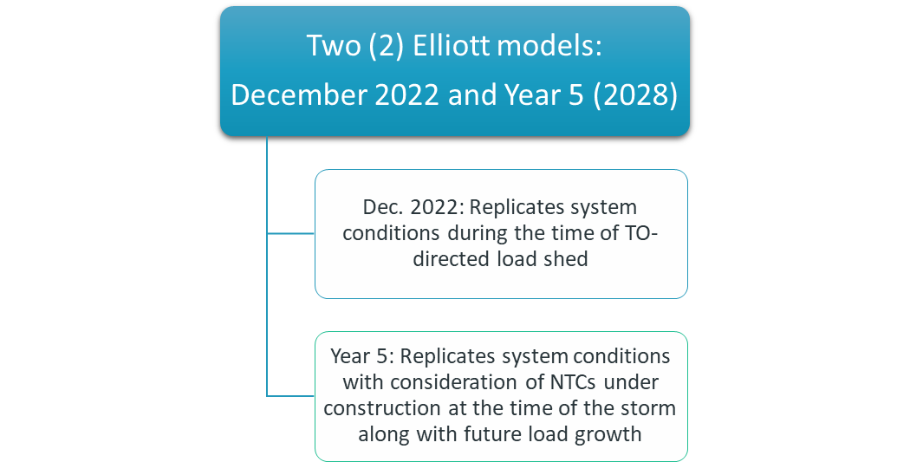

Figure . Elliott Extreme Weather Model Development

### : PLANNING STANDARDS

The 2024 JCSP study evaluated potential system improvements that would provide the most practical and cost-effective means of resolving operational issues and serving future loads for normal conditions (N-0) and single contingency (N-1) scenarios using, at a minimum, the following planning standards:

* No facility loaded above 100% for N-0 and N-1 contingencies
* No voltages above 105% for N-0 and N-1 contingencies (110% maximum under light load conditions for AECI facilities only)
* No voltages below 95% for N-0 conditions
* No voltages below 90% for N-1 contingencies
* Local planning criteria as submitted by Transmission Owners (TO)
* Each region may utilize additional transmission benefits as evaluated by each region in their respective regional processes.

### : NEEDS ASSESSMENT

The SPP 2024 ITP steady-state assessment process, as defined in section 4.2 of the SPP ITP manual, was used for the needs assessment in the 2024 JCSP. The needs in the SPP 2024 ITP were determined by performing a system intact and N-1 contingency analysis (TPL-001-5 P1 and P2.1 events). For all cases, facilities 60 kV and above in SPP and AECI were monitored. For the light load case, facilities 60kV and above in SPP and 345 kV and above in AECI were monitored.

Due to the impact of Winter Storm Elliott on the SPP and AECI Systems, two extreme winter cases were created based on that 2022 storm: one for the winter of 2025 and another for the winter of 2028. The needs in these cases were only evaluated under N-0 conditions.

AECI voltage and thermal needs were determined using specific JCSP models where the SPP ITP cases were used as the base case. Topology, rating, impedance updates, and loads were increased to match levels used in the AECI 2023 Long Range Plan (LRP).

Economic needs were also identified from the 2024 ITP needs assessment posting by filtering within the 2024 JCSP area of interest. SPP determines economic needs based on the congestion score associated with a constraint (comprised of a monitored element and a contingent element pair). This score is calculated by multiplying the number of hours a constraint is congested in the model by the average shadow price of that constraint. Unique constraints with a congestion score of $50,000/MW were identified as economic needs within each future scenario. Futures assumptions can be found in the 2024 ITP scope document[5].

After performing the needs assessment, potential areas of need were identified and presented to the IPSAC on August 23, 2024. A detailed description of each need can be found in the August 23 IPSAC materials[6].

Figure . Reliability and Economic Needs Presented

Figure . Winter Weather Needs Presented

### 1.7: SOLUTION ANALYSIS

AECI and SPP requested stakeholders submit solutions to the needs presented. AECI and SPP jointly evaluated solution submissions provided by staff and stakeholders based on the following criteria:

* Proposed solution effectively addresses the need
* Proposed solution does not create any additional reliability issues
* Proposed solution creates a reliability benefit to both entities
* Proposed solution provides adjusted production cost[7] (APC) savings to AECI or SPP (Discretionary)

The 2024 ITP solutions informed the 2024 JCSP study, as the same processes for evaluating solutions were used. This allowed AECI and SPP to pull from existing data to determine how these solutions solved needs within the joint study.

## SECTION 2: RECOMMENDATIONS

### : PROJECTS OF INTEREST

Most of the identified projects of interest originate from the 2024 ITP winter weather grouping due to being located within the 2024 JCSP area of interest and additional projects were selected from the JCSP solution submissions. SPP identified both qualitative and quantitative approaches to develop the grouping to address needs driven by extreme winter weather in the 2024 ITP. For solutions related to the target area of southwest Missouri, SPP selected a group of projects that mitigated the most voltage violations. The table below lists the projects of interest for potential cost sharing in the 2024 JCSP study and the projects that are sourced from the 2024 ITP have more refined cost estimates:

Table . 2024 ITP/JCSP projects considered for potential cost-sharing

| **General Description** | **State** | **Miles** | **Cost** |
| --- | --- | --- | --- |
| Aurora - Reeds Spring 161 kV Rebuild | MO | 23.7 | $37,904,869 |
| Aurora H.T. - Monett 161 kV Ckt 1 Rebuild | MO | 11.5 | $22,835,547 |
| Branson North- Ozark Dam 161 kV Ckt 1 Rebuild | MO | 7.1 | $12,375,255 |
| Buffalo Flats - Delaware 345 kV New Line | KS/OK | 154.6 | $484,090,326 |
| Compton Ridge - Roark Creek[8], Table Rock - Nixa, Reeds Spring - Branson Northwest 161 kV Line Taps | MO | 2 | $70,122,330 |
| Delaware - Monett 345 kV Ckt 1 New Line | OK/MO | 114.5 | $342,608,905 |
| Monett - North Branson 345 kV Ckt 1 New Line | MO | 47.2 | $165,800,962 |
| Ozark Dam - Forsyth North - Ozark South 161 kV Voltage Conversion | MO | 28.2 | $38,032,729 |
| Reed Springs - North Branson - Northwest Branson - Branson North 161 kV Rebuild | MO | 9.9 | $17,108,010 |
| Second 161/69kV Lamar Transformer8 | MO | NA | $7,641,150[9] |
| Rebuild Nodaway – Maryville 161kV line8 | MO | 5.4 | $5,495,400 |
| New Lacygne – Clinton – Barnett – Mariosa8 345 kV line | MO | 156 | $348,000,000 |

Three additional options for a project in the Kinzie area are being considered for benefit as well, with feasibility discussions ongoing.

Figure . Branson 345 kV EHV Overlay

The 345 kV overlay project from Buffalo Flats to Delaware to Monett to North Branson was selected to enhance the robustness and resiliency of the transmission system in the southern Missouri area near Branson to address recent extreme winter weather events. Many of the needs identified in this area were low voltage that were driven by a lack of supporting EHV transmission and generation deliverability to the region during Winter Storm Elliott. This project showed substantial reliability benefits.

The 345 kV overlay project involves the construction of approximately 316 miles of 345 kV transmission lines, extending from southern Kansas to northeastern Oklahoma and into southwestern Missouri. This project offers significant advantages by enhancing the transmission of low-cost energy to eastern areas of the SPP footprint as well as AECI. Additionally, it boosts power transfer capability and improves reactive power support in the area, delivering substantial benefits in terms of reliability and resilience.

The project has also shown to release bottlenecked generation by eliminating system constraints that limit access to lower-cost generation in the target area. Ultimately, the project contributes to a more robust transmission system, better equipped to handle increased load growth and withstand extreme weather conditions.

Figure . Branson 161 kV Underlay

In addition to the EHV overlay, SPP identified multiple winter weather needs in the Branson area. As a result, SPP selected a series of 161 kV upgrades to further enhance the benefits of the 345 kV project. These projects were selected to strengthen the 161 kV system in the area and to facilitate the connection of the 345 kV projects nearby to ensure adequate transfer capability is available.

There are negative impacts from this project on the Reeds Spring 161/69 kV transformer that increase the loading above 120% and an overload of the Table Rock-Table Rock (SPA) 69 kV line that will require additional improvements to correct. These negative impacts appear in the AECI-built JCSP models.

To facilitate the 345 kV to 161 kV connection, SPP recommends that the Compton Ridge to Roark Creek, Table Rock to Nixa, and Reeds Spring to Branson Northwest 161 kV lines be tapped near the point at which they intersect to serve as the point of interconnection for the 345 kV overlay project.

Along with the winter weather needs, persistent operational congestion (ITP manual section 4.4[10]) has appeared in recent years throughout the 161 kV corridor from Monett to Ozark Dam. To relieve this congestion, the corridor would be rebuilt to allow for adequate power flow to occur in real time.

Finally, the 69 kV line from Ozark South to Forsyth to Ozark Dam, which is out of service due to environmental and safety concerns, would be rebuilt to 161 kV to support voltage and complement the rebuilds of the remaining 161 kV projects in the corridor. The 345 kV line would allow for increased transfer into the area while the other rebuilds would adequate distribution while avoiding congestion.

Figure 6. Lamar 161/69 kV Circuit 2 Transformer

The southwest Missouri region is the recipient of significant transmission buildout in the 2024 ITP due to the conditions observed during Winter Storm Elliott. With these projects solving multiple congestion points on SPP’s eastern seam, more power is allowed to flow east and begins to congest the 161/69 kV Lamar transformer upon loss of the 345 kV line from Blackberry to Jasper. This transformer also becomes congested during times of heavy power flow on the 161 kV north-to-south corridor. Adding a second 161/69 kV transformer at Lamar would relieve the congestion and increase the potential APC savings in this area.

This project will likely impact the underlying 69 kV lines in the area, requiring some facilities to be open-ended during periods of increased transfers. Additional costs may be added to this project to cover the costs of new facilities needed to return the level of reliability to this area where loads will be non-radial during normal operation.

Figure . Nodaway – Maryville 161kV rebuild

The Nodaway – Maryville 161 kV rebuild relieves congestion on the 161 kV corridor southward. It is the limiting element in the following flowgates: Maryville-Nodaway for the loss of (FLO) St. Joe-Cooper, Maryville-Nodaway FLO Braddyville-Clarinda, Maryville-Nodaway FLO Sibley-Ketchem, Maryville-Nodaway FLO Creston-Maryville along with several others.

Figure 8. Lacygne - Clinton – Barnett - Mariosa 345 kV

A new 156-mile line from Lacygne - Clinton - Barnett - Mariosa 345 kV was evaluated as part of the 2024 JCSP and provides significant potential benefit for AECI and a portion of future SPP generation not yet assigned load. The project includes the construction of 345/161 kV substations at Clinton and Barnett with a single transformer at each location. This project also solved numerous reliability needs identified in the JCSP, as well as unlocks lower-cost SPP generation to the west allowing it to flow eastward.

Recent extreme winter weather events highlighted extreme power flows from east to west across the high voltage corridor through mid-Missouri. This 345 kV transmission project was effective at reducing transmission flows while also eliminating or postponing several reliability needs on the lower voltage system. It also served as a strong source to large load centers around Clinton and the Lake of the Ozarks area in mid-Missouri.

### : PRELIMINARY ADJUSTED PRODUCTION COST BENEFIT EVALUATION

The following two tables show the preliminary potential adjusted production cost savings of the projects in table 1. Future assumptions can be found in the 2024 ITP scope5, and information on adjusted production cost savings can be found in SPP’s benefit metrics manual7.

Table . Future 1 Preliminary APC benefit of 2024 JCSP projects of interest

|  |  |  |  |  |
| --- | --- | --- | --- | --- |
| Region Name | F1 Y5 APC Benefit | F1 Y10 APC Benefit | F1 20Y APC Benefit | F1 40Y APC Benefit |
| MISO | $75,313,727 | $13,116,976 | $34,854,514 | ($108,166,747) |
| Saskatchewan | $15,723,849 | $34,252,577 | $438,197,827 | $623,067,844 |
| MHEB | ($1,375,606) | $3,980,445 | $57,067,753 | $88,434,365 |
| SPP Regional | $31,401,506 | $11,994,887 | $103,766,524 | $88,600,626 |
| SPP OTHER | $105,724,871 | $122,788,815 | $1,476,149,643 | $1,986,567,636 |
| MISO OTHER | ($64,669) | $40,164 | $673,286 | $1,146,507 |
| AECI | $21,320,505 | $66,246,751 | $864,945,681 | $1,250,547,192 |
| TVA | $31,047,673 | $12,708,639 | $114,205,234 | $104,994,516 |

Table . Future 2 Preliminary APC benefit of 2024 JCSP projects of interest

|  |  |  |  |  |
| --- | --- | --- | --- | --- |
| Region Name | F2 Y5 APC Benefit | F2 Y10 APC Benefit | F2 20Y APC Benefit | F2 40Y APC Benefit |
| MISO | ($24,033,839) | $18,905,648 | $304,628,898 | $507,609,620 |
| Saskatchewan | $7,810,189 | $19,870,427 | $256,721,358 | $368,013,964 |
| MHEB | ($5,154,134) | $6,826,249 | $103,231,050 | $165,647,844 |
| SPP Regional | $48,982,284 | ($22,959,728) | ($407,933,270) | ($715,521,629) |
| SPP OTHER | $92,584,093 | $143,075,946 | $1,778,768,084 | $2,467,966,929 |
| MISO OTHER | ($44,345) | $26,776 | $451,221 | $770,503 |
| AECI | $38,571,470 | $95,547,410 | $1,232,501,190 | $1,764,519,185 |
| TVA | $31,611,219 | $17,666,414 | $180,916,242 | $203,747,760 |

The benefits shown are SPP’s calculation of APC benefit for the SPP region, SPP Other, and external regions. “SPP Other” includes generators within the SPP footprint that are not yet assigned to load. This represents the potential benefit to SPP based upon future generation and load assumptions. SPP utilized the event file used in the 2024 ITP solution evaluation milestone to calculate the futures 1 and 2[11] APC benefits.

### : STUDY RECOMMENDATIONS

SPP & AECI recommend further cost sharing and feasibility discussions related to the projects included in table 1, with a goal for decisions about which projects of interest will move into the cost-sharing negotiations phase to be made by mid-2025.

### 2.4: FUTURE STUDY PROCESS ENHANCEMENTS

SPP and AECI remain committed to reviewing the current process with stakeholders to determine what process enhancements can and should be made to make subsequent performance of this process more effective and ensure projects are appropriately identified.

1. [AECI-SPP Joint Operating Agreement](https://www.spp.org/spp-documents-filings/?id=18603)
2. [12/15/2023 IPSAC Materials](https://www.spp.org/Documents/70701/SPP-AECI%20IPSAC%20Meeting%20Materials%2020231215.zip)
3. [3/22/2024 IPSAC Materials](https://www.spp.org/Documents/71308/AECI-SPP%20IPSAC%20Meeting%20Materials%2020240322.zip)
4. [8/2/2024 IPSAC Materials](https://www.spp.org/Documents/72052/AECI-SPP%20IPSAC%20Meeting%20Materials%2020240802.zip)
5. <https://www.spp.org/documents/72249/2024%20itp%20assessment%20scope%20v1.4.pdf>
6. <https://www.spp.org/Documents/67764/SPP-AECI%20IPSAC%20Meeting%20Materials%2020220824.zip>
7. <https://www.spp.org/search?q=benefit%20metrics>
8. AECI-owned facility.
9. Additional needs on the 69 kV network are anticipated. Impact evaluations are ongoing.
10. https://www.spp.org/documents/70408/itp%20manual%20version%202.15.pdf
11. <https://www.spp.org/documents/72249/2024%20itp%20assessment%20scope%20v1.4.pdf>