

**2025 INTEGRATED TRANSMISSION PLANNING ASSESSMENT SCOPE**

By SPP Engineering

Published on 05/01/2024

Version 2.0

# Revision History

|  |  |  |  |
| --- | --- | --- | --- |
| Date or version number | Author | Change Description | Comments |
| 01/16/2024 v.1.0 | SPP Staff | Initial MOPC-approved version | Approved by MOPC January 2024 |
| 05/01/2024 v.2.0 | SPP Staff | Added key assumptions table for Resiliency in section 3 | Approved by MOPC April 2024 |
| v.3.0 | SPP Staff | Added Resiliency Model Inputs and updated objectives of each assumption |  |

Contents

Revision History i

Section 1: Overview 4

Objective 4

Section 2: Modeling Details and Assumptions 5

Model year definitions 5

Market Economic Model Overview 5

Futures 5

Must-Run Units 7

Curtailment Price 7

Hurdle rates and interchange 7

Resource Plan 8

Conventional Generator Prototypes 8

Resource Accreditation 8

Planning Reserve Margin Values 9

New Resource Allocation and Assignment 9

State Renewable Portfolio Standards 11

Resource Plan Modeling 11

Section 3: Resiliency Condition Analysis 13

Model development 14

Resiliency Condition #1 - Summer Scenario 14

Resiliency Condition #2 - Winter scenario 14

Resiliency Condition #3 - Load Additions in Future 2 15

Pre-final model assumptions 15

Contingency Analysis 19

Section 4: Solution Evaluation & Portfolio Development 20

Persistent Economic Operational Solution Evaluations 20

Flowgates 20

Manual Commitment of Generators 20

Consolidation 20

Section 5: Final Assessments 23

Sensitivities 23

Voltage Stability Assessment 23

Section 6: Schedule 25

Section 7: Changes in Process and Assumptions 27

# Section 1: Overview

This document presents the scope and schedule of work for the 2025 Integrated Transmission Planning (ITP) Assessment. The Economic Studies Working Group (ESWG) and Transmission Working Group (TWG) are responsible for the creation and review of this document with approvals from the Market Operations and Policy Committee (MOPC) and the board of directors (Board).

## Objective

The objective of the 2025 ITP Assessment is to develop a regional transmission plan that provides reliable and economic delivery of energy and facilitates achievement of public policy objectives, while maximizing benefits to the end-use customer. This 2025 ITP Assessment Scope contains assumptions to be utilized in the 2025 ITP Assessment that are not standardized in the [ITP Manual](https://www.spp.org/spp-documents-filings/?id=19027). These documents should be reviewed together for a comprehensive view of the 2025 ITP process and assumptions.

# Section 2: Modeling Details and Assumptions

## Model year definitions

The 2025 ITP seasonal models for the 2025 ITP years two, five, and ten are listed below based on the [SPP Model Development Procedure Manual](https://www.spp.org/spp-documents-filings/?id=18607) developed by the Model Development Advisory Group.

|  |  |
| --- | --- |
| 2025 ITP & NERC TPL Assessment Study Years | |
| ITP & TPL Assessment (Study Year) | 2025 |
| Year 1 | 2025 |
| Year 2 | 2026 |
| Year 5 | 2029 |
| Year 10 | 2034 |

Table 1: Model Year Definitions

## Market Economic Model Overview

### Futures

The ESWG developed two futures with input from the Strategic Planning Committee (SPC) and TWG. The MOPC reviewed preliminary versions of both futures in October 2023 and their final versions in January 2024.

|  | DRIVERS | | | | | | |
| --- | --- | --- | --- | --- | --- | --- | --- |
| KEY ASSUMPTIONS | Future 1 – Reference Case | | | | Future 2 – Emerging Technologies | | |
| Year 2 | Year 5 | Year 10 | | Year 5 | Year 10 | |
| Peak Demand Growth Rates | As submitted in load forecast | Increase due to electric vehicle growth | | | Higher Increase due to electric vehicle growth & additional loads | | |
| Energy Demand Growth Rates | As submitted in load forecast | Increase due to electric vehicle growth | | | Higher Increase due to electric vehicle growth & additional loads | | |
| Natural Gas Prices | Current industry forecast (Hitachi & S&P Global) | Current industry forecast (Hitachi & S&P Global) | | | Current industry forecast (Hitachi & S&P Global) | | |
| Coal Prices | Current industry forecast (Hitachi) | Current industry forecast (Hitachi) | | | Current industry forecast (Hitachi) | | |
| Emissions Prices | Current industry forecast (Hitachi) | Current industry forecast (Hitachi) | | | Current industry forecast (Hitachi) | | |
| Fossil Fuel Retirements | Current forecast | Based on IRP feedback; subject to generator owner (GO) review | | | Based on IRP feedback; subject to generator owner (GO) review | | |
| Environmental Regulations | Current regulations | Current regulations | | | Current regulations | | |
| Demand Response[1] | As submitted in load forecast | As submitted in load forecast (Separate load forecast may be submitted for use in Resource Planning) | | | As submitted in load forecast (Separate load forecast may be submitted for use in Resource Planning) | | |
| Distributed Generation (Solar) | As submitted in load forecast | As submitted in load forecast | | | As submitted in load forecast | | |
| Energy Efficiency | As submitted in load forecast | As submitted in load forecast | | | As submitted in load forecast | | |
| Resource Siting | N/A | Per [ITP Resource Siting Manual](https://www.spp.org/spp-documents-filings/?id=19027) | | | Per [ITP Resource Siting Manual](https://www.spp.org/spp-documents-filings/?id=19027) | | |
| Storage | Existing + RARs | **6.6** | | **13.2** | **9.6** | | **19.2** |
| Total Renewable Capacity | | | | | | | |
| Solar (GW) | Existing + RARs | **9.1** | **18.4** | | **19.1** | **26.1** | |
| Wind (GW) | Existing + RARs | **48.9** | **55.2** | | **54.8** | **61.1** | |

Table 2: Future Drivers

### Must-Run Units

Must-run designations for SPP areas will be assigned to co-generation, nuclear, landfill gas, and hydroelectric units, unless an exception is requested during the generation review and approved by the ESWG. Co-generation units will be identified based on EIA 860 data, as well as Hitachi simulation-ready data. If a unit was originally identified as a must-run in a previous study, but was removed as an exception, it will not be identified as a must-run in the 2025 ITP. External areas will have the same criteria, with the deviation that external co-generation units will be assigned a must-run status subject to SPP review.

### Curtailment Price

An automatic repower will be assumed for all wind units after 10 years of being in service and the projected production tax credits (PTC) will be applied. For solar and wind resources impacted by the IRA, curtailment prices will reflect the PTC with the multiplier and one adder for applicable solar and wind resources.

### Hurdle rates and interchange

Hurdle rates for all futures will be based upon the latest vendor data set. However, prior to and during the MEM benchmarking and initial year 5 and year 10 MEM builds, SPP and ESWG will be reviewing the reasonableness of the latest vendor data set hurdle rates and respective interchange. SPP and ESWG may utilize, as appropriate, previous ITP MEMs in this review. This review may result in adjustments to the MEM hurdle rates and/or other economic model parameters that impact MEM interregional “economy-energy” transactions. Any ESWG-approved adjustments and MEM interchange results will be documented in the ITP assessment report.

## Resource Plan

### Conventional Generator Prototypes

Generator prototype parameters will be set using the Cost and Performance Characteristics of New Generating Technologies, Annual Energy Outlook 2023 – EIA (EIA-AEO).[2] Industrial combustion turbine (CT) will be the default. Members will be allowed to request an exception to the combustion turbine utilizing the single-shaft combined cycle (CC) or 90% carbon capture combined cycle prototypes from the EIA-AEO. Exceptions must be approved by the ESWG. Table 3 below details the characteristics of the approved prototypes in 2022 dollars for currency values.

| Generation Type | Data Source | Technology Type | Size (MW) | Total Capital Cost ($/kW) | Variable O&M ($/MWh) | Fixed O&M ($/kW-yr) | Heat Rate (Btu/kWh) |
| --- | --- | --- | --- | --- | --- | --- | --- |
| Combined Cycle (CC) | **EIA AEO ’23** | **90% CCS** | **377** | **$3,019.00** | **$6.57** | **$31.06** | **7,124** |
| Combined Cycle (CC) | **EIA AEO ’23** | **Single Shaft** | **418** | **$1,330.00** | **$2.87** | **$15.87** | **6,431** |
| Combustion Turbine (CT) | **EIA AEO ’23** | **Industrial** | **237** | **$867.00** | **$5.06** | **$7.88** | **9,905** |

Table 3: Generator Prototype Parameters

### Resource Accreditation

SPP staff will complete a resource accreditation assessment[3] for all market economic model scenarios to accredit resources for summer and winter planning reserve margin assessments (PRM).

SPP staff will categorize renewable resources into two categories, Tier 1 and Tier 2. Tier 1 resources include existing renewables with long-term firm transmission service or future renewables requested by a utility’s integrated resource planning template response submitted to SPP during 2025 ITP Scope development. All remaining renewable resources will be considered Tier 2.

Two Effective Load Carrying Capability (ELCC) percentage values for each season (summer and winter) will be used based upon SPP’s latest ELCC study results. A total accreditation amount for each resource type in each scenario and season will be determined. Tier 1 resources will be given an accreditation value consistent with the ELCC percentage based on the Tier 1 amount. The total accreditation available from Tier 1 resources will be subtracted from the total accreditation value. Tier 2 resources will receive the remaining accreditation on a pro-rata basis. The following visual will replicate the process.

Figure

### Planning Reserve Margin Values

For the summer season, a PRM value of 16% will be used. For the winter season a 27% reserve margin value will be used for 2029 and 35% reserve margin will be used for Year 10.

### New Resource Allocation and Assignment

100% of requested non-policy wind, solar, and storage resources will be assigned to requesting utilities. The specific resource assignments will be made in parallel with the siting milestone for the 2025 ITP.

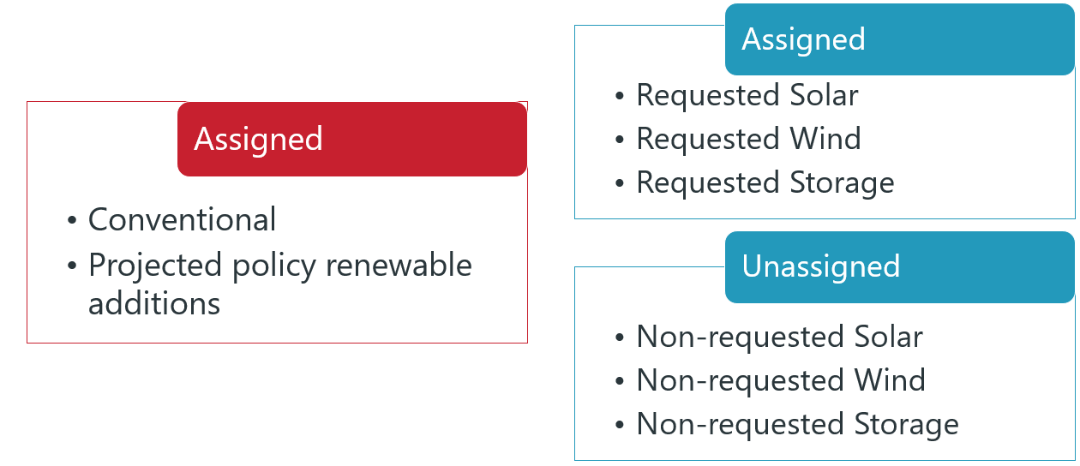

Figure : Resource Assignments

Policy additions will be met with 50 percent wind and 50 percent solar, based on the active, non-suspended GI queue requests.

Renewables will be allocated first based upon resource planning template responses to those utilities forecasting additions based on either the excess or deficit scenarios described in figures 3 and 4 below:

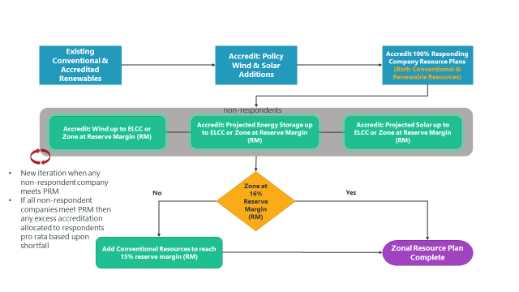

Figure : Summer Resource Accreditation - Excess Scenario

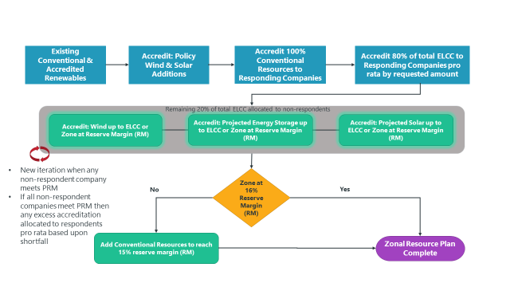

Figure : Summer Resource Accreditation - Deficit Scenario

In the excess scenario, responding companies receive the full amount of renewables requested in their resource planning template. The remaining ELCC will be allocated to non-responding companies pro rata (all fuel types) based upon shortfall, capped at PRM.

In the deficit scenario, responding companies will receive 80% of total ELCC pro rata by requested amount. The remaining 20% of ELCC will be allocated to non-responding companies pro rata (all fuel types) based upon shortfall, capped at PRM.

### State Renewable Portfolio Standards

The following values will be used in accordance with Section 2.2.1.3 of the ITP Manual:

| State | RPS Type | Generation Type | Capacity- or Energy- Based | Year 5 % | Year 10 % |
| --- | --- | --- | --- | --- | --- |
| Colorado | Mandate | Both | Energy | 30 | 30 |
| Kansas | Goal | Both | Capacity | 20 | 20 |
| Minnesota | Mandate | Both | Energy | 25 | 50[4] |
| Missouri | Mandate | Both | Energy | 15 | 15 |
| New Mexico | Mandate | Both | Energy | 40 | 584 |
| North Dakota | Goal | Both | Energy | 10 | 10 |
| Oklahoma | Goal | Both | Capacity | 15 | 15 |
| South Dakota | Goal | Both | Energy | 10 | 10 |
| Texas | Mandate | Both | Capacity | 0[5] | 05 |

Table : ITP RPS by State

### Resource Plan Modeling

As noted in the ITP Manual, the market powerflow models (MPM) will contain system topology consistent with their respective market economic model (MEM). This topology consistency does not include the reactive power settings of the resource plans because they are not considered in the MEM. The following parameters will guide how the resource plans, both internal and external, are modeled with regards to reactive settings, such as maximum and minimum VAR support and voltage schedule. Stakeholders are given the opportunity to review certain reactive device settings during the MPM review period described in Section 2.3.2 of the ITP Manual.

All resources included in the internal or external resource plans (excluding distributed generation, such as rooftop solar) will be modeled as directly injecting power at the point of interconnection (*i.e.,* ESWG-approved site). Maximum and minimum reactive capability of generators will be determined by utilizing a .95 power factor and the maximum real power capability of the resource. Resources sited where existing generation is already interconnected will follow the voltage schedule and remote bus determination of the existing resource. The following information is resource fuel type specific and references settings observed in the powerflow modeling software utilized in the ITP process. The following settings apply to both the internal and external resource plans.

#### Conventional Generation

The control mode for conventional generation will be set to “Not a wind machine.” The voltage schedule (*i.e.,* vsched) will be set at 1.015 per unit for system peak models and 1.00 per unit for off- peak models, unless a voltage set point warning is observed. For sites with no existing generation, the remote bus will be the point of interconnection of the new resource.

#### Solar, Wind, or Energy Storage Resources

The control mode for renewable and energy storage resources will be “+ or – Q limits based on WPF[6]”. WPF will be set at .95. The voltage schedule will be set at 1.015 per unit for system peak models and 1.00 per unit for off peak models, unless a voltage set point warning is observed. For sites with no existing generation, the remote bus will be the point of interconnection of the new resource.

# Section 3: Resiliency Condition Analysis

Over recent years, SPP and its neighbors have been experiencing more frequent extreme weather conditions. As a result, SPP has adopted a new process of studying resiliency in the ITP. Goals of this process include assessing a select group of solutions to resiliency issues that address:

1. Problems driven from high-impact, low frequency events;
2. Common real-time issues not currently in the ITP process; or
3. Violations across multiple conditions

The purpose is to focus on solutions that provide the greatest benefit to the region with respect to the frequency of extreme events. Two power flow model sets will be built for evaluation as a part of this effort, while a third condition will be included in the Future 2 economic scenario. The two model sets will represent system conditions in the extreme for winter and summer. These model sets will also include consideration of duration of the resiliency condition.

Figure

## Model development



### Resiliency Condition #1 - Summer Scenario

Staff will build an extreme summer weather scenario model set based upon staff and stakeholder agreement on a set of summer weather system stressors and the expected effect to the transmission system. Extreme conditions considered in the extreme summer weather scenario will include, but not limited to:

* Effect of prolonged high temperatures
* Drought
* Severe weather
* Low wind
* Imports/Exports
* Generation maintenance outages
* Appropriate use of Emergency-Only or Behind-the-Meter generator availability

Three models representing the same years as the standard base reliability models will be built. Considering the potential intensity of probabilistic conditions, staff and TO’s will have the flexibility to utilize all NERC approved operating standards to resolve needs.

### Resiliency Condition #2 - Winter scenario

Staff will build an extreme winter weather scenario model set based upon staff and stakeholder agreement on a set of winter weather system stressors and the expected effect to the transmission system. Extreme conditions considered in the extreme winter weather scenario will include, but not limited to:

* Effect of extreme cold and duration
  + Load Levels
  + Wind
  + Precipitation
  + Ice Dams
  + Capacity reductions or temperature related outages
* Fuel availability
* Imports/Exports
* Generation maintenance outages
* Appropriate use of Emergency-Only or Behind-the-Meter generator availability

Three models representing the same years as the standard base reliability models will be built. Considering the potential intensity of probabilistic conditions, staff and TO’s will have the flexibility to utilize all NERC operating approved standards to resolve needs.

### Resiliency Condition #3 - Load Additions in Future 2

SPP has seen impressive year-over-year load growth, beating forecasted numbers. Our third considered component of resiliency includes a higher-than-expected EV adoption and load growth. Additionally, expected growth potential for large spot loads, like data centers, will be included in this future case. These additional loads will be approved through the load review process by ESWG.

This will be included in the Future 2 model sets.

### Pre-final model assumptions

Following considerations listed above, Staff will assemble a table detailing high level Resiliency model assumption details. These details are split into four tables: one for each future (F1, F2) and one for each year (Y5, Y10). These tables highlight the differences between the base MEM models and the resiliency MEM models. While the final numbers may vary, these initial numbers act as guideposts in the initial simulation of the R-MEM models.

Table 5 - Future 1, Year 5 Resiliency Key Assumptions

|  |  |  |  |  |
| --- | --- | --- | --- | --- |
| **FUTURE 1, YEAR 5 - KEY ASSUMPTIONS** | **Future 1 – Resiliency** | | **Future 1 – Reference** | |
| **5** | | **5** | |
| **Season** | **Winter** | **Summer** | **Winter** | **Summer** |
| **System Impact Days** | **1 month** | | **-** | |
| **Peak Load** | 58,771 | 69,042 | 56,674 | 65,968 |
| **Wind Cap Factor** | 19.2%-38.6% | 11%-27.4% | Reference | Reference |
| **Solar Cap Factor** | 8% | 24% | Reference | Reference |
| **Conv Unavailability Rate\*** | 3.7%-68% | 1%-35.7% | Reference Maint. + Forced Outage Rates | Reference Maint. + Forced Outage Rates |
| **Available Total MW (Ecomax Conv + Actual Wind + Actual Solar)** | 77,404 | 83,660 | 77,404 | 83,660 |
| **Available Conventional** | 68,902 | 68,902 | 68,902 | 68,902 |
| **Operating Reserves** | 18,633 | 14,618 | 20,730 | 17,692 |
| **Interchange** | 1,500-2,500 | 1,500-2,500 | 1,500-2,500 | 1,500-2,500 |

Table 6 - Future 1, Year 10 Resiliency Key Assumptions

|  |  |  |  |  |
| --- | --- | --- | --- | --- |
| **FUTURE 1, YEAR 10 - KEY ASSUMPTIONS** | **Future 1 – Resiliency** | | **Future 1 – Reference** | |
| **10** | | **10** | |
| **Season** | **Winter** | **Summer** | **Winter** | **Summer** |
| **System Impact Days** | **1 month** | | **-** | |
| **Peak Load** | 61,914 | 72,472 | 59,705 | 68,962 |
| **Wind Cap Factor** | 19.2%-38.6% | 11%-27.4% | Reference | Reference |
| **Solar Cap Factor** | 8% | 24% | Reference | Reference |
| **Conv Unavailability Rate\*** | 3.7%-68% | 1%-35.7% | Reference Maint. + Forced Outage Rates | Reference Maint. + Forced Outage Rates |
| **Available Total MW (Ecomax Conv + Actual Wind + Actual Solar)** | 79,605 | 87,363 | 79,605 | 87,363 |
| **Available Conventional** | 68,902 | 68,902 | 65,707 | 65,707 |
| **Operating Reserves** | 17,691 | 17,891 | 19,900 | 18,401 |
| **Interchange** | 1,500-2,500 | 1,500-2,500 | 1,500-2,500 | 1,500-2,500 |

Table 7 - Future 2, Year 5 Resiliency Key Assumptions

|  |  |  |  |  |
| --- | --- | --- | --- | --- |
| **FUTURE 2, YEAR 5 - KEY ASSUMPTIONS** | **Future 2 – Resiliency + Spot Load** | | **Future 2 – Reference + Spot Load** | |
| **5** | | **5** | |
| **Season** | **Winter** | **Summer** | **Winter** | **Summer** |
| **System Impact Days** | **1 month** | | **-** | |
| **Peak Load** | 65,238 | 75,602 | 62,910 | 71,940 |
| **Wind Cap Factor** | 19.2%-38.6% | 11%-27.4% | Reference | Reference |
| **Solar Cap Factor** | 8% | 24% | Reference | Reference |
| **Conv Unavailability Rate\*** | 3.7%-68% | 1%-35.7% | Reference Maint. + Forced Outage Rates | Reference Maint. + Forced Outage Rates |
| **Available Total MW (Ecomax Conv + Actual Wind + Actual Solar)** | 80,462 | 89,052 | 80,462 | 89,052 |
| **Available Conventional** | 68,902 | 68,902 | 68,902 | 68,902 |
| **Operating Reserves** | 15,224 | 13,450 | 17,552 | 17,112 |
| **Interchange** | 1,500-2,500 | 1,500-2,500 | 1,500-2,500 | 1,500-2,500 |

Table 8 - Future 2, Year 10 Resiliency Key Assumptions

|  |  |  |  |  |
| --- | --- | --- | --- | --- |
| **FUTURE 2, YEAR 10 - KEY ASSUMPTIONS** | **Future 2 – Resiliency + Spot Load** | | **Future 2 – Reference + Spot Load** | |
| **10** | | **10** | |
| **Season** | **Winter** | **Summer** | **Winter** | **Summer** |
| **System Impact Days** | **1 month** | | **-** | |
| **Peak Load** | 72,663 | 79,910 | 70,070 | 76,039 |
| **Wind Cap Factor** | 19.2%-38.6% | 11%-27.4% | Reference | Reference |
| **Solar Cap Factor** | 8% | 24% | Reference | Reference |
| **Conv Unavailability Rate\*** | 3.7%-68% | 1%-35.7% | Reference Maint. + Forced Outage Rates | Reference Maint. + Forced Outage Rates |
| **Available Total MW (Ecomax Conv + Actual Wind + Actual Solar)** | 88,291 | 93,938 | 88,291 | 93,938 |
| **Available Conventional** | 68,902 | 68,902 | 71,463 | 71,463 |
| **Operating Reserves** | 15,628 | 14,028 | 18,221 | 17,899 |
| **Interchange** | 1,500-2,500 | 1,500-2,500 | 1,500-2,500 | 1,500-2,500 |

**Season** – 2025 ITP Resiliency considered two separate seasons, and each season has unique variables for understanding system performance. As such, each season has its own sub column highlighting the variations between the two seasons.

**System Impact Days** – Resiliency will be modeled in reflecting periods of time. For each season, one month will be modified to reflect the resiliency peak conditions. These months are January and July, which typically reflect the most significant weather periods for SPP.

**Peak Load** – Peak load reflects the peak load for the given resiliency season. To calculate this number, several steps must be taken. Step 1 is determining the peak load number itself, which is calculated by finding the difference ratio between historical coincident peaks and ITP non-coincident peaks and applying that to the 2025 ITP Peak load. The objective of step 1 is to develop a forecasted load within our footprint that shows elevated system performance beyond a 50/50 weather normalized ITP load forecast. Step 2 involves applying the peak load across the footprint according to historic peak event performance. The objective of step 2 is to ensure areas see elevated load in line with what was forecasted during historic peak events. Example: not all areas saw an average elevated load during Uri. Some areas saw increased load over forecasted (expected result) while others saw no change over their 50/50 forecasted load (unexpected result). Step 2 addresses spreading the increased load in a manner expected according to historic data, not evenly distributed.

**Wind Cap Factor** ­– Capacity Factor (also Cap Factor or CF) is measured by evaluating a generators total real MW output for a given period of time divided by its total max potential MW output.



Wind and solar vary in their output with the resource (wind and sunshine) being intermittent. For PROMOD to build generator profiles, PROMOD needs to know the total energy output for the generator for a given period of time and the capacity factor. Applying this percentage to a reduced MWh output reduces the output performance of those generators during specific a period of time. The objective with reducing the capacity factor was to understand how wind droughts can impact system performance during peak events. Wind cratered during Uri for several days and SPP has also seen periods of very low wind during warmer months.

**Solar Cap Factor** – Capacity Factor (also Cap Factor or CF) is measured by evaluating a generators total real MW output for a given period of time divided by its total max potential MW output.



Solar is a unique resource with the forecasted scale not matching existing footprint. Industry expectations drove default data, with a potentially more conservative approach including the impact of frost, ice, dust, and extreme temperature impacting performance. Output of solar leaned on the conservative side, reducing output of solar by 25% of reference expected performance. This may vary more based on SPP’s footprint, but given the limited data on historic performance, numbers closer to default were selected.

**Conv. Unavailable Rate** – Because of the variety of reasons for outages during resiliency events (fuel, heat, cold, ice, wind, staffing, etc.) the performance of conventional generators has been combined and sorted by fuel type and state. This reflects not just forced outage rates, but also generators that were unavailable for any number of reasons including maintenance outages that were unplanned or planned, along with fuel supply limitations. The percentage range here shows the lowest possible unavailability rate to the highest possible within the footprint.

**Available Total MW** – Available Total MW shows the peak amount of capacity available during this month period including: ecomax conventional generators, actual wind, and actual solar.

**Available Conventional** – Available conventional resources during these peak events can be an indicator of system stress test. With less available conventional generation, one expects to see more frequent and severe congestion.

**Operating Reserves** – Any clarified number of reserves for generation calculated to be available for dispatch **not including outage or de-rates**. Calculated by comparing peak load estimates and total accredited available generation. Actual reserves vary depending on the outage curves and capacity factor outputs of generators hour-by-hour and is calculated using PROMOD’s algorithms to determine generator output.

**Interchange** – Considering the reliance on interchange during Uri, firm import and export numbers have been assumed. While this number is not expected to change, increasing imports may be used to offset congestion or extreme emergency energy hours in lieu of new projects. SPP and stakeholders agreed to keep imports to a minimum and reducing exports to meet internal needs first, while also understanding increasing imports may make more financial sense or be a viable option for solutions development.

## Contingency Analysis

SPP will conduct contingency analysis on both extreme weather conditions for the entire SPP region, with a variable number of transmission and/or generator outages driven by certain weather events. Statistics along with stakeholder and staff conversation will determine the scale of such weather events. Criteria will be developed to identify resiliency needs, to be approved by the TWG and ESWG.

Solution Development

* Results from the contingency analysis will be included as information to support recommended needs alongside other needs identified throughout the 2025 ITP Assessment.

# Section 4: Solution Evaluation & Portfolio Development

## Persistent Economic Operational Solution Evaluations

### Flowgates

SPP will perform the persistent operational needs assessment prior to the 2025 ITP benchmarking milestone for further investigation and validation of the year 2 economic models. As part of the 2025 ITP needs assessment, SPP will make a recommendation to working groups on whether or not to address persistent operational needs according to ITP Manual section 4.4

### Manual Commitment of Generators

Some transmission system issues require the manual commitment of generation by SPP in the Integrated Marketplace to provide relief on the system. The make-whole payments avoided when a proposed solution is included in the model will be considered in the solution’s benefit. Each solution’s one-year benefit-to-cost (B/C) ratio and its ability to reduce or eliminate the need for manual commitments will be considered during project selection.

## Consolidation

It was approved by TWG and ESWG for 2025 ITP Scope consolidation to be determined after the initial posting of the scope in January 2024 to incorporate impacts of resiliency analysis and latest 20-Year Assessment. This section will be revisited by TWG and ESWG prior to the process execution and may be updated as approved by TWG, ESWG, and MOPC. SPP must consolidate the future-specific portfolios into a single set of projects to determine a recommended plan. The methodology by which this consolidation will occur is based on individual project performance. A systematic approach to evaluate each project’s merits and an SPP-developed narrative of each project’s drivers will guide the decision for inclusion in the recommended plan. Three different scenarios could occur during the consolidation of the future-specific portfolios into a recommended plan:

1. The same project is addressing the same or similar needs in both futures
2. Different projects are addressing the same or similar needs in both futures
3. A project addresses certain needs only in one future

Projects applicable to scenario one will be considered for the recommended plan. Projects applicable to scenarios two and three will be given a score based on the point system detailed in Table 5. Each project will be awarded points based on its performance or ability to meet six different considerations, up to 100 total possible.

|  |  |  |  |
| --- | --- | --- | --- |
| No. | Considerations | Points Possible | Threshold |
| 1 | 40-year (1-year) APC B/C in Selected Future | 50 | 1.0 (0.9) |
| 40-year (1-year) APC B/C in Opposite Future | 0.8 (0.7) |
| 40-year (1-year) APC Net Benefit in Selected Future ($M) | N/A |
| 40-year (1-year) APC Net Benefit in Opposite Future ($M) | N/A |
| 2 | Congestion Relieved in Selected Future (by need(s), all years) | 10 | N/A |
| Congestion Relieved in Opposite Future (by need(s), all years) | 10 | N/A |
| 3 | Operational Congestion Costs or Reconfiguration ($M/year or hours/year) | 10 | >0 |
| 4 | New EHV | 7.5 | Y/N |
| 5 | Mitigate Non-Thermal or Resiliency Issues | 7.5 | Y/N |
| 6 | Long Term Viability (EHV in 2022 20-Year Assessment or addresses constraints that are limiting ARR feasibility)[7] | 5 | Y/N |
| Total Points Possible | | **100** |

Table : Consolidation Considerations Scoring Table

For two projects (P1 and P2) applicable to scenario two, points for consideration one will be calculated as follows:

1. Test B/C thresholds in opposite future
   * If project has less than 0.8 40-year B/C in opposite future, zero points will be awarded
   * If project meets 0.8 40-year B/C threshold in opposite future, continue calculations
   * If project has less than 0.7 1-year B/C in all years of opposite future, zero points will be awarded
   * If neither of the above conditions are met, continue calculations
2. Calculate 40-year net adjusted production cost (APC) benefits
   * Net APC benefitP1,AVE
   * Net APC benefitP2,AVE
   * Net APC benefitMax = Maximum(Net APC benefitP1,AVE,Net APC benefitP2,AVE)
3. Calculate points awarded

${Points awarded}_{P1,\%}=50×\frac{{Net APC benefit}_{P1,AVE}}{{Net APC benefit}_{Max}}$

${Points awarded}_{P2,\%}=50×\frac{{Net APC benefit}_{P2,AVE}}{{Net APC benefit}_{Max}}$

For individual projects (P1) applicable to scenario three, points for consideration one will be calculated as follows:

1. Test B/C threshold in opposite future
   * If project has less than 0.8 40-year B/C in opposite future, zero points will be awarded
   * If project has less than 0.7 1-year B/C in all years of opposite future, zero points will be awarded
   * If project has at least 1.0 40-year B/C in opposite future, 50 points will be awarded
   * If project meets 0.8 40-year B/C threshold in opposite future, but is less than 1.0, continue calculations
   * If none of the above conditions are met, continue calculations
2. Calculate net APC benefits
   * Net APC benefitP1,AVE
   * Net APC benefitP1’,AVE = Net APC benefitP1,AVE with 1.0 40-year B/C in opposite future
3. Calculate points awarded

${Points awarded}_{P1,\%}=50×\frac{{Net APC benefit}_{P1,AVE}}{{Net APC benefit}_{P1',AVE}}$

Points for consideration two will be calculated as the percentage of total congestion relieved on the needs addressed by the project, multiplied by the points possible.

$$Points awarded= {10×\% Congestion relieved}_{F1, addressed needs}+ {10×\% Congestion relieved}_{F2, addressed needs}$$

Points for consideration three will be calculated based on the severity of an operational issue that the project is expected to address, as a percentage of the operational needs criteria[8] multiplied by the points possible, up to 10.

$$Points awarded= \left(\frac{{\$ of congestion cost}_{24 months}}{\$10M}\right)×10$$

OR

$$Points awarded= \left(\frac{{Hours of system reconfiguration}_{12 months}}{X\% ×8,760}\right)×10$$

All points possible for considerations four, five, and six will be awarded if the project meets the description of the consideration.

For projects applicable to scenario two, the project with the highest score will be considered the favorable project based on the systematic approach. Projects applicable to scenario three with a total score of 70 or greater will be considered for the final recommended plan.

SPP may use engineering judgement or other analysis to support or oppose results of the systematic approach described above. SPP will bring consolidation results and a recommendation for all projects selected for a future-specific portfolio to the ESWG and TWG for review and feedback.

# Section 5: Final Assessments

## Sensitivities

Sensitivities will be conducted on the final consolidated portfolio in both futures to measure the flexibility of the portfolio with respect to the uncertainties of certain assumptions. Economic analysis will be performed for the sensitivities below:

* High and low natural gas prices
* High and low demand levels
* High and low solar and wind levels

Additional sensitivities will be determined via stakeholder survey leading up to this analysis, and will be documented in the ITP assessment report.

## Voltage Stability Assessment

A voltage stability assessment will be conducted in both futures using the final consolidated portfolio to assess the megawatt transfer limit under, but not limited to, the following two scenarios:

* Increasing renewable generation in SPP and decreasing conventional thermal generation in SPP.
* Increasing renewable generation in SPP and decreasing conventional thermal generation in external areas.

Any additional scenarios being considered will be brought before the TWG for discussion, and will require TWG approval to be formally included in the analysis.

The transfer limit will be determined by examining voltage performance during power transfers across SPP. The stability assessment consists of a dispatch analysis to determine if the dispatched generation in the applicable year 10 models can be dispatched without the occurrence of voltage collapse or thermal violations.

# Section 6: Schedule

The 2025 ITP assessment began in July 2023 and will be completed by October 2025.[9] Figure 6 and Table 6 detail the study timeline.

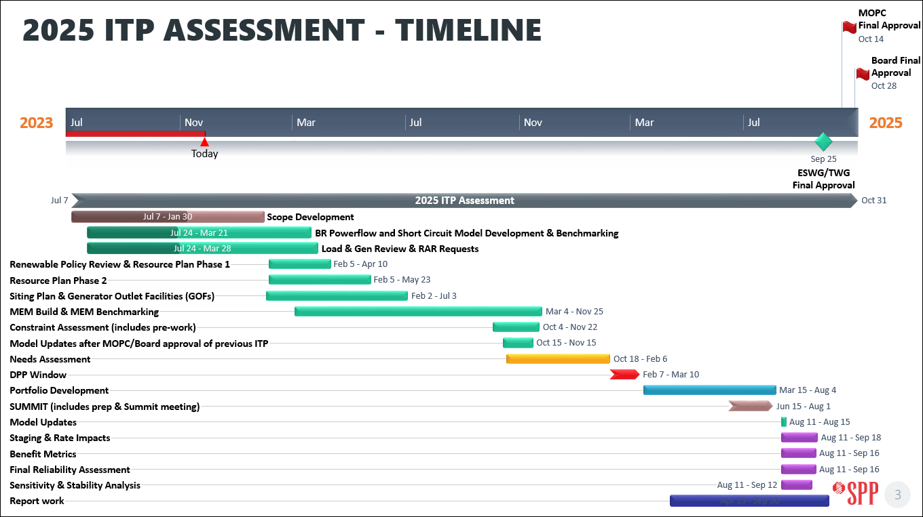

*Figure 6: 2025 ITP Timeline*

|  |  |  |  |
| --- | --- | --- | --- |
| Milestone Name | Group(s) to Review/Endorse | Start Date | Completion Date |
| Scope Development | ESWG, TWG, MOPC, SPC | Jul 2023 | Jan 2024 |
| Base Reliability Powerflow & Short Circuit Model Development | TWG | Jul 2023 | Mar 2024 |
| Load and Generation Review | ESWG, TWG, MDAG | Jul 2023 | Mar 2024 |
| Renewable Policy Review | ESWG | Jan 2024 | Apr 2024 |
| Renewable Resource Plan (RP1) | ESWG, CAWG | Feb 2024 | Mar 2024 |
| Conventional Resource Plan (RP2) | ESWG | Mar 2024 | May 2024 |
| Siting Plan & Generator Outlet Facilities (GOFs) | ESWG | Feb 2024 | Jul 2024 |
| Powerflow Model Development | TWG | Mar 2024 | Nov 2024 |
| Short Circuit Model Development | TWG | Mar 2024 | Nov 2024 |
| Economic Model Development | ESWG | Mar 2024 | Dec 2024 |
| Model Benchmarking | ESWG, TWG | Jul 2024 | Sep 2024 |
| Model Updates after 2023 ITP Approval MOPC/Board (NTC/Re-evaluations) | TWG | Oct 2024 | Nov 2024 |
| Constraint Assessment | TWG | Oct 2024 | Nov 2024 |
| Needs Assessments | ESWG, TWG | Oct 2024 | Feb 2025 |
| Detailed Project Proposal (DPP) Window | ESWG, TWG | Feb 2025 | Mar 2025 |
| Solutions Development | ESWG, TWG | Feb 2025 | Apr 2025 |
| Project Grouping | ESWG, TWG | Apr 2025 | May 2025 |
| Study Cost Estimates |  | Jun 2025 | Aug 2025 |
| Summit |  | July 2025 | July 2025 |
| Final Portfolio Development | ESWG, TWG | July 2025 | Aug 2025 |
| Portfolio Optimization / Consolidation | ESWG, TWG | Aug 2025 | Sep 2025 |
| Project Staging | ESWG, TWG | Aug 2025 | Sep 2025 |
| Benefit Metrics Calculations | ESWG | Aug 2025 | Sep 2025 |
| Stability Analysis | TWG | Aug 2025 | Sep 2025 |
| Sensitivity Analysis | ESWG | Aug 2025 | Sep 2025 |
| Final Reliability Assessment | TWG | Aug 2025 | Sep 2025 |
| Review Draft Report with Recommended Solutions | ESWG, TWG | Aug 2025 | Sep 2025 |
| Final Report with Recommended Solutions | ESWG, TWG | Sep 2025 | Sep 2025 |
| RSC, SPC, SSC | October 2025 | |
| MOPC, SPP Board |

Table : 2025 ITP Schedule

# Section 7: Changes in Process and Assumptions

To protect against changes in process and assumptions that could present a significant risk to the completion of the 2025 ITP Assessment, any changes to this scope or assessment schedule must be appropriately vetted and follow the process outlined in the stakeholder accountability section of the ITP Manual as time allows.

1. As defined in the [SPP Model Development Procedure Manual](https://www.spp.org/spp-documents-filings/?id=18607)
2. <https://www.eia.gov/outlooks/aeo/assumptions/pdf/elec_cost_perf.pdf>
3. These PRM and accreditation assessments are a proxy calculation for SPP's Resource Adequacy process not intended to replicate the final results or replace the process entirely.
4. Mandates are set after year 10; interpolated values shown
5. Texas has a goal of 1,965 MW by August of 2025
6. Wind power factor
7. Similar termination points determined if they are located no more than 1 station (sub-station, switching station, or other station as identified in the SPP Model) away or within 15 linear miles as noted in SPP BP 7650
8. Flowgate congestion cost totaling more than $10M over the last 24 months or system reconfiguration through an agreed-upon operating guide implemented 25 percent of year.
9. Dates are subject to change.